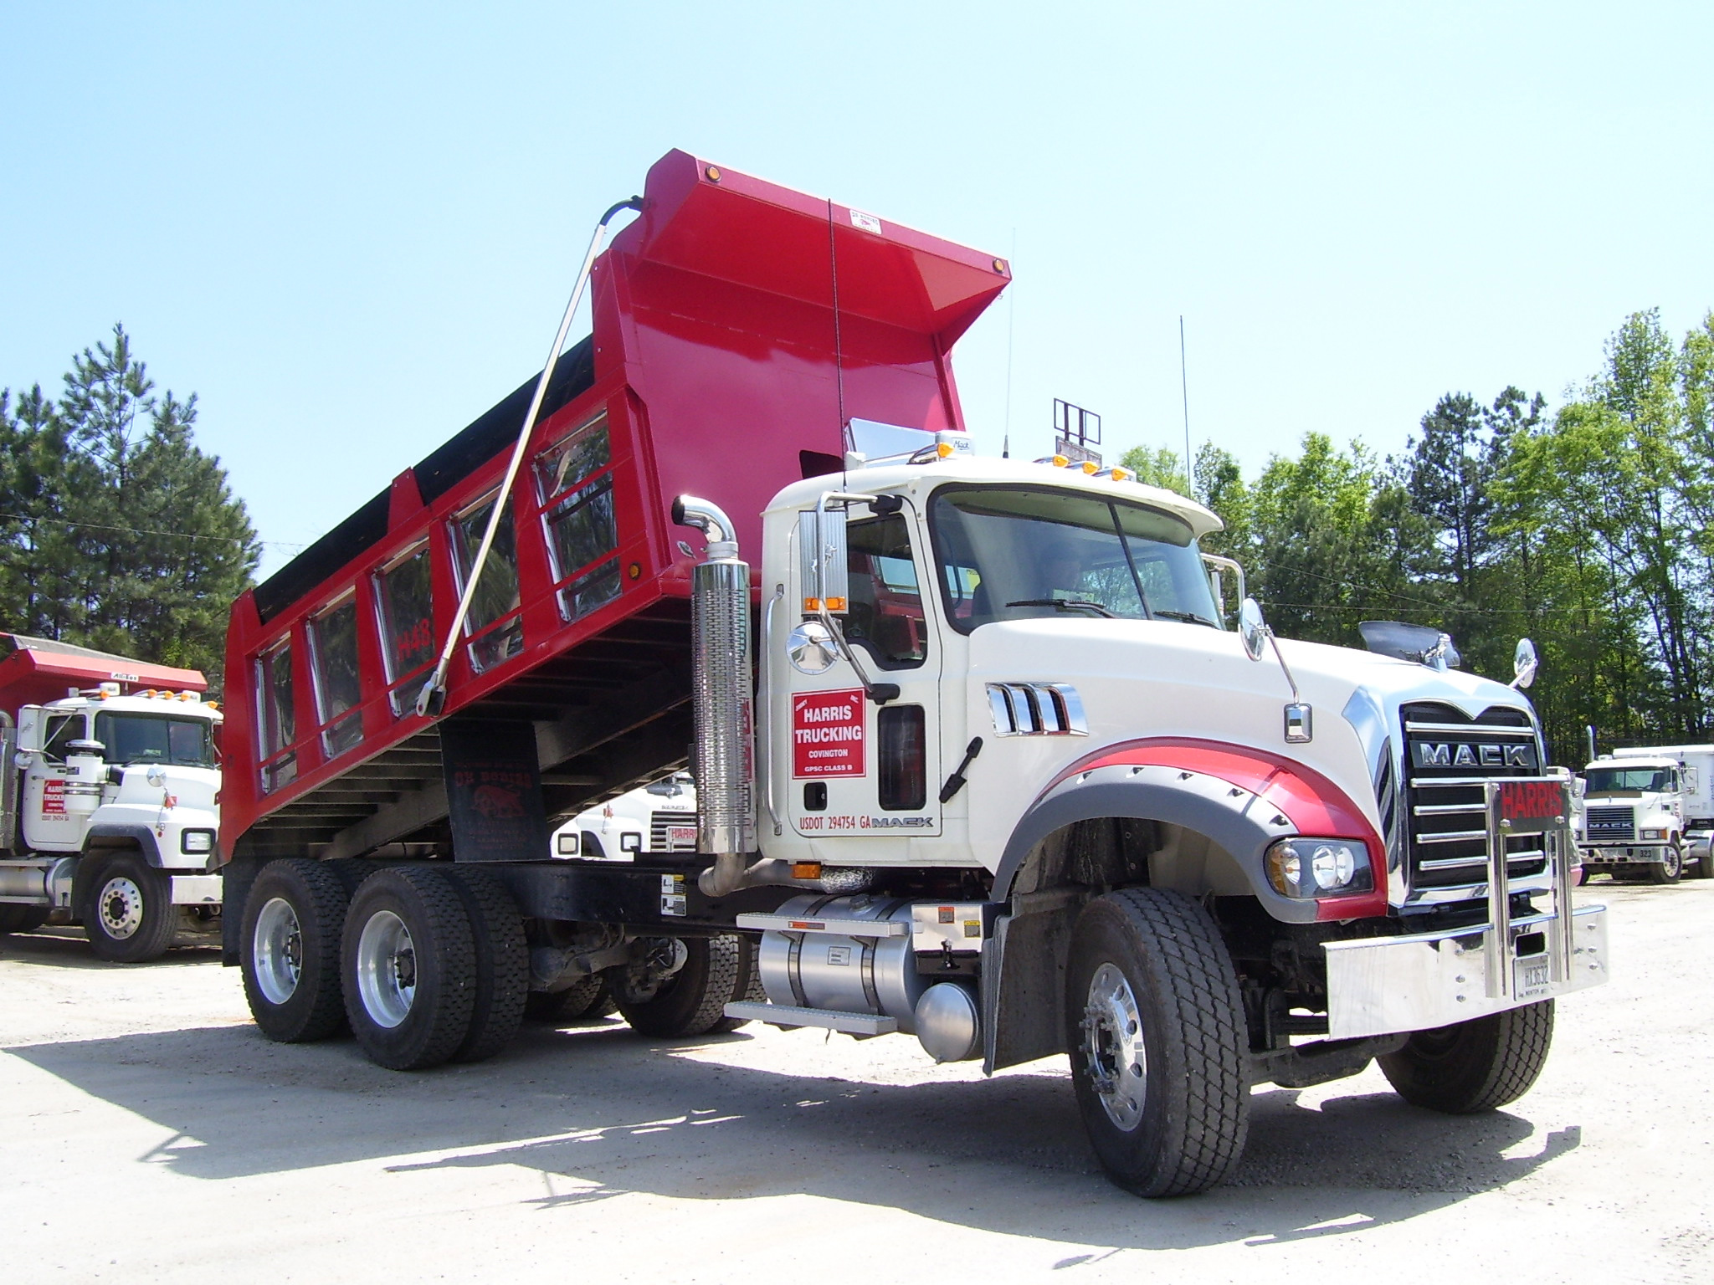 JIMMY HARRIS TRUCKING, INC. 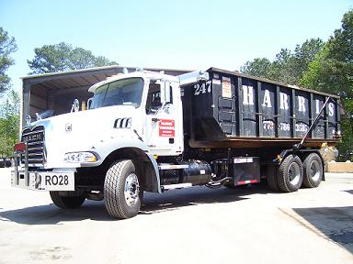
9101 OLD ATLANTA HWY 8163 OLD ATLANTA HWY
COVINGTON, GA 30014 COVINGTON, GA 30014
770-786-0061 770-786-3585
770-786-3593 (FAX) 770-786-6384 (FAX)
Jackie Hardy Wade Sockwell
770-266-8329 (MOBILE) 678-725-2528 (MOBILE)

CREDIT APPLICATION

DATE

NAME OF ACCOUNT

MAILING ADDRESS

PHYSICAL ADDRESS

PHONE # CONTACT

FAX # EMAIL

SOCIAL SECURITY #/FEDERAL TAX ID. #

TRADE REFERENCES : (Please include phone and account numbers)

1.

2.

3.

I hereby give Jimmy Harris Trucking, Inc. permission to have access to my credit information for the above references.

Signed Printed Name

ARE YOU LISTED WITH DUN & BRADSTREET CREDIT SERVICES?

BANK REFERENCE: CHECKING ACCT. #
******************************************************************************
TERMS OF ACCOUNT: ACCOUNTS BILL DAILY AND ARE DUE UPON RECEIPT OF INVOICE. IF AN INVOICE REACHES 60 DAYS, THE ACCOUNT WILL BE PLACED ON TEMPORARY C.O.D. IF AN INVOICE REACHES 75 DAYS, THE ACCOUNT WILL BE PLACED ON C.O.D. AND IS SUBJECT TO LEGAL ACTION.

